SOUTH CHINA SEA HERALD
Vol. 58 • No. 12
1 April 2025 | SPECIAL EDITION

BREAKING NEWS: Merlion Defends the Coast in Mythic Midday Melee
SOUTH CHINA SEA, OFF THE COAST OF SINGAPORE — 1:00 PM (SGT)
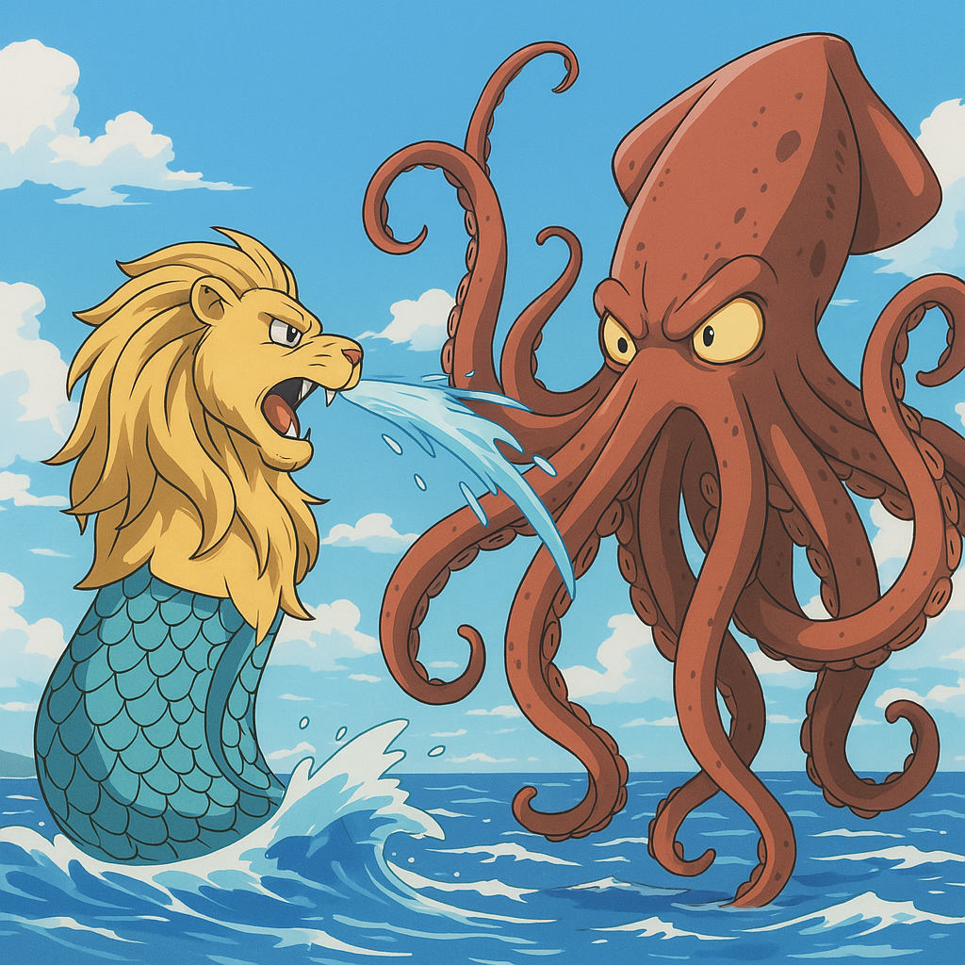
In an event that stunned beachgoers and sent a shockwave through maritime traffic, a battle of titanic proportions erupted just off the coast of Singapore today, as the legendary Merlion clashed with a previously undocumented—and enormous—deep-sea squid over the open waters of the South China Sea.
A Battle of Legends
Tourists and locals watched in awe as the battle unfolded with cinematic intensity. The Merlion, shimmering with silvery-white scales and blue runic light, took a defensive stance atop a pillar of swirling seawater. The squid lunged, attempting to ensnare the guardian in its many arms, but was met with a devastating geyser blast from the Merlion’s mouth—a torrent strong enough to shatter the clouds above.
Fighter jets from nearby bases were scrambled, but the Singaporean government quickly issued a "Do Not Interfere" protocol, recognizing the sacred nature of the clash.
For over 45 minutes, the ocean churned as the two behemoths exchanged blows, each fueled by ancient magic and primal instinct. The squid gained an upper tentacle midway through the battle, nearly pulling the Merlion into the deep. But in a final, awe-inspiring moment, the Merlion summoned a vortex of water laced with starlight and unleashed a divine roar, launching the squid far beyond the horizon in a blinding flash of light.
The Guardian Prevails
At exactly 1:47 PM, the ocean calmed. The Merlion raised its head to the sky, releasing a final roar before submerging once more, disappearing beneath the waves as mysteriously as it had arrived. No injuries were reported onshore, and a spontaneous round of applause erupted from Sentosa Beach, where thousands had gathered to witness the myth become reality.
Government Statement
Singapore’s Ministry of Mythical Affairs released a short statement:
"We thank the Merlion for its protection. The coast is secure, and all maritime activity will resume by tomorrow morning. Please do not attempt to summon sea spirits without a permit."

Victory for the Lion of the Sea
The people of Singapore can rest easy tonight, knowing their guardian remains ever watchful. The Merlion has once again proven that when the seas rise with danger, the heart of the lion shall not falter.
🦁🌊 TDBuOV9sMXYzXzRoM19NM3JsMTBu
Sponsored by: Mer-Lime Energy Drink – Awaken Your Inner Roar
Photos and sketches by on-site artist, Lin Xiu Mei

